Rudra Chinhara

Write a class STRING that can be used to store strings, add strings, equate string, output string
Strings
GitHub Link

CODE
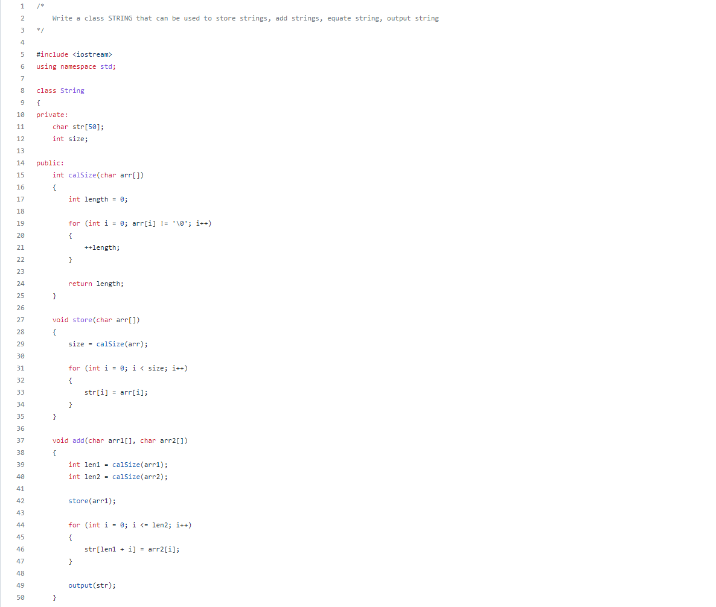
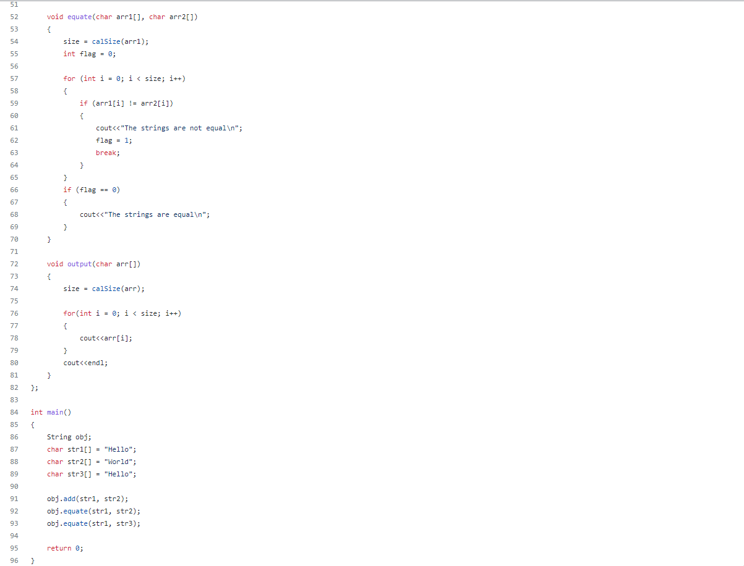

OUTPUT
